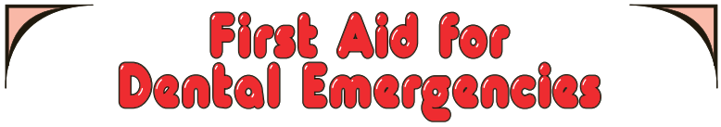
Follow the instructions below when
a child has a dental emergency.
- In all situations, reassure the child.
- If any blood is involved, it is recommended that you wear gloves.
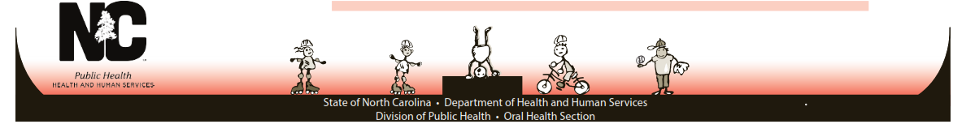
BLEEDING AFTER  LOSING A BABY TOOTH | - Place a clean folded gauze pad, cloth or paper towel over the bleeding area  - Have the child bite on the gauze with pressure for 15 minutes.  This procedure may be repeated.  - Make sure child refrains from frequent rinsing.  - If bleeding persists, SEE A DENTIST!
BROKEN BRACES  AND WIRE | - Broken wires can be covered with wax or gauze until child can be seen by an orthodontist.  - DO NOT remove wire embedded in the check, tongue or gums.  - THE CHILD SHOULD SEE THEIR ORTHODONTIST IMMEDIATELY!
BROKEN TOOTH | - Gently clean dirt from the injured area with warm water.  - Place a cold compress on the face over the injured area.  - Locate and save any broken tooth fragments if possible.  - SEE A DENTIST IMMEDIATELY!
CUT OR BITTEN TONGUE,  LIP OR CHEEK | - Clean area with a clean, wet cloth.  - Apply pressure with cloth to stop bleeding.  - Apply ice to the swollen or bruised areas. If bleeding does not stop after 15 minutes, or with pressure, child should be seen by a dentist or doctor
KNOCKED OUT  PERMANENT TOOTH | - Find the tooth.  - Handle the tooth by the crown, not the root!  - Gently replace the tooth in its socket and hold the tooth in place.  - A tooth that is quickly reimplanted has a good chance of being saved!  - If the tooth cannot be inserted into the socket, put the tooth into “Sav-A-Tooth”, or a cup of fresh milk. Do not put the tooth into tap water.  - SEE A DENTIST IMMEDIATELY
POSSIBLE  BROKEN JAW | - The child’s jaw line may appear distorted.  - Immediately call 911!  - Keep child still and calm.  - Make sure child can breathe.  - Try to keep child from moving.
TOOTHACHE  OR ABSCESS | - Rinse the mouth vigorously with warm salt water to remove any food debris.  - DO NOT place aspirin on the site of the toothache because it may cause burning to the gum tissue. If the face is swollen, place a cold compress on the outside of the cheek.  - SEE A DENTIST AS SOON AS POSSIBLE

